

**Pain Relief Foundation**

I wish to support the Pain Relief Foundation by

making regular donations with a bankers order.

BANKERS ORDER

**Name & full address of your bank**

To: …………………. Bank

Address: …………………………………………….

…………………………………………….

…………………………………………….

…………………….. Postcode …………….

Please pay to HSBC Bank plc, 4 Dale Street, Liverpool , L69 2BZ (**40-29-08**) for the credit of Pain Relief Foundation (**A/c No. 84075366**)

The sum of £ ……………. (Words) ……………….……….

on the (Date) …..…. day of (Month) ..……..…………..20…..

And on the same day of each month until further notice.

Signed …………………………………. Date …………… 20 ….…

Mr/Mrs/Ms/Title ……………………………………………………….

Account Number ………………………………………………………

**Registered Charity Number 1156227** 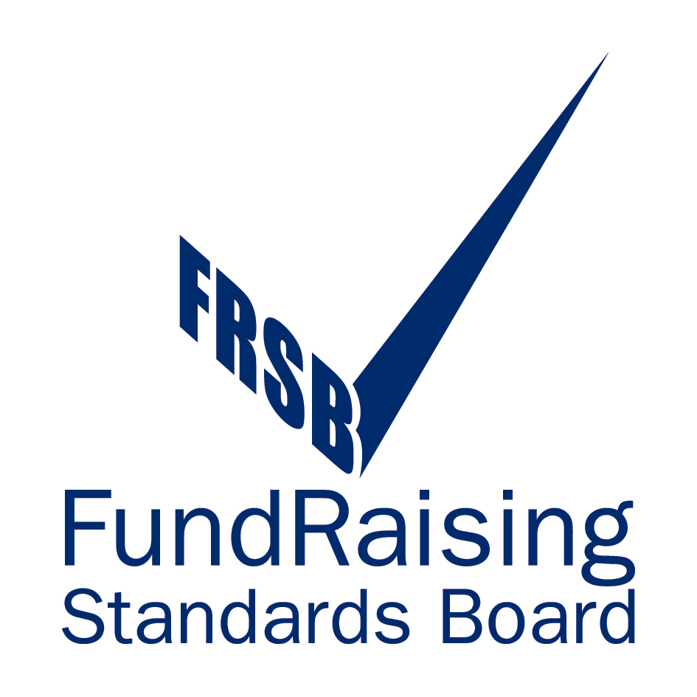 

**Registered Charity Number 1156227**

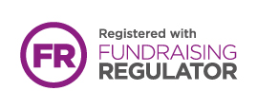

**Gift Aid**

The Foundation can claim tax on your donation at the basic rate of tax. This has the effect of increasing the value of your donation to the Foundation at no extra cost to you. Here is an example of how this works:

**Basic (20%) Rate Tax Payer**

A basic rate tax payer makes a donation of £20.00

The Foundation will claim ‘Gift Aid Tax Relief’ £ 5.00

Gross value of the donation to the Foundation is £25.00

However, if you are a higher rate tax payer (40%) then there are benefits to you also, which have the effect of reducing the actual net amount you donate, without the Foundation losing. This is because higher rate tax payers will be allowed to reclaim the difference between the 20% rate recovered by the Charity and the rate of tax paid. Here is an example

**Higher (40%) Rate Tax Payer**

A **higher rate** tax payer makes a donation of £20.00

You claim additional tax relief on the **gross**

value of the donation shown above (£25.00)

The recovered tax will be (£ 6.25)

Your Net outlay is £13.75

*Note:* If you pay income tax or capital gains tax, the Pain Relief Foundation can reclaim tax from the Inland Revenue at the rate of 25p for each £1 donation you make. All that you need to do is to sign the declaration below:

*I confirm that all donations that I make on any date after the date of this declaration should be treated under Gift Aid rules and I authorise the Pain Relief Foundation to reclaim tax on my donations.*

Signed ……………………………… Date ……………………..

Note: Tax will be reclaimed at the rate of 25p for each £1 you donate and you should, therefore, have paid income tax or capital gains tax of the amount we shall reclaim.

Please send this form with your donation to:

Pain Relief Foundation, Clinical Sciences Centre, University Hospital Aintree, Liverpool L97AL